!!!!Study Guide!!! This test will cover- The Rock Cycle, Weathering, Erosion and Shoreline Features
- Fill in the blanks and center arrows using the following words: Heat & pressure, Igneous, Metamorphic, compaction & cementation, Sedimentary.
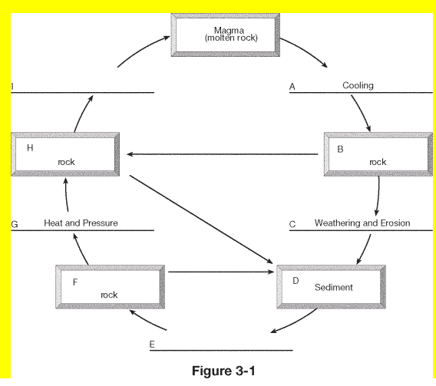
- What are the two sources of energy for the rock cycle? Earth’s ___________ ___________ and the _________.
- Write mechanical or chemical next the the following statements to describe what kind of weathering they are.
A chain is rusty_______________________ A rock experiences frost wedging___________________
Heat causes cracks in concrete____________________ Acid dissolves a rock________________________
Hitting a rock with a hammer______________________ A penny turning green_______________________
- What kind of climate would cause the most ersion and thus the most soil? ___________________________ ________________________________________________________________________________________
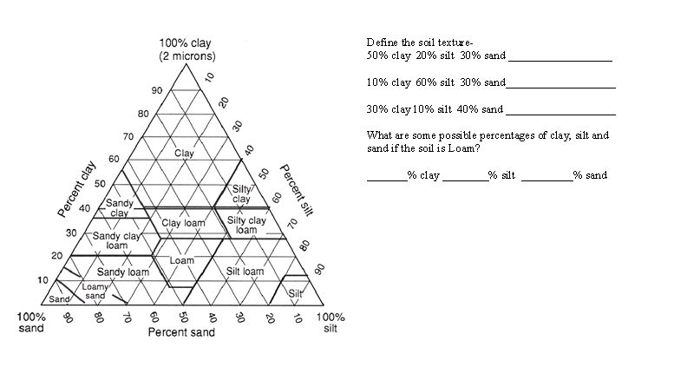
- How do plants contribute to soil? How do they prevent erosion?

- What is the difference between the longshore transport and the longshore current? ________________________ _________________________________________________________________________________________________
- 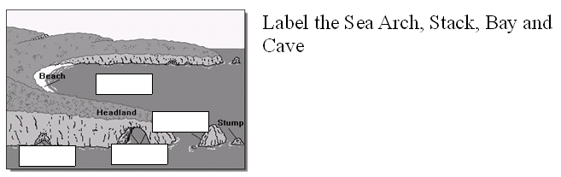
- Explain the purpose of each of the following structures and how each disrupts the natural processes.
  - Dam _____________________________________________________________________________________
  - Seawall __________________________________________________________________________________
  - Groin ____________________________________________________________________________________
  - Jetties ____________________________________________________________________________________

- What is the difference between beach dredging and beach nourishement? ________________________________ ________________________________________________________________________________________________________________________________________________________________________________________________________

